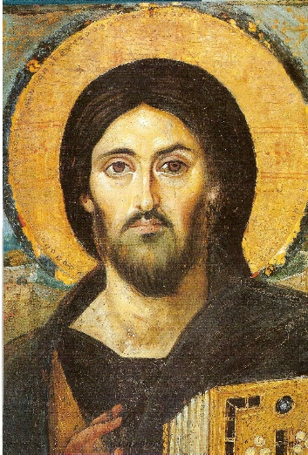
Sacred Windows Icon Workshop Christ the Pantocrator April 6th- 10th, 2020 Holy Week
at St. James Episcopal Church, Ormond Beach
38 S. Halifax Drive
Ormond Beach, FL

According to St. Mark’s Gospel, chapter 4, the disciples, terrified by the furious storm that came upon their fishing boat, called out to Jesus for help. His powerful Word stilled the wind and the waves. The disciples asked themselves still terrified by their ordeal, “Who is this? Even the wind and waves obey Him!” Mark 4:41

The word Pantocrator and the idea behind it appear in the book of Revelation. God speaks in Revelation 1:18, “I am the Alpha and the Omega, the Lord Who is, Who was and Who is to come, the “Pantocrator” (Almighty). Normally the icon of Christ Pantocrator is the most remote of all the conventional poses. Christ is distant from us and sometimes His face is stern. Yet in other iconic depictions such as that of the Balkan Churches, we find the Pantocrator with dancing eyes. His face is sharp. His mouth tiny with the effort of suppressing a smile and his fingers thin and dancing where they hold the Book. The Gospel book in the icon is closed, but Jesus knows what is inside; the Good news of God’s love, of the destruction of sin and death and the enemies of God’s Church as well as life everlasting for the faithful who have endured and whose names are written in the Book of Life. So what a wonderful icon to have and hold in our homes. An image of the God who constantly looks upon us; sees us in our sorrow and strife and comforts us, upholds us and stills the wind and waves that afflict us as well.

This course will introduce students to the methods and principles of icon writing. By the end of the course, each participant will complete and take home their icon. Iconography is not a hobby that can be learned in a week but is a vocation that requires the mastering of various skills over the years.
Teacher, Marcia Allison has been studying and writing icons since 2009.

For more information Marcia’s cell phone number is 813-417-7525 or email m.allison0408@gmail.com
Monday April 6, 2020 -Friday April 10, 2020
Daily Morning Prayer in the Chapel 8:30am
Studio Time 9am – 11:30 ending with Noon Day Prayers
Lunch will be served at 12 Noon in the Parish Hall.
Afternoon session 1- 4pm will vary with time available for 1:1 instruction, group instruction and personal time.
We will have a blessing of the icons Eucharist service on Saturday.
Optional Spiritual Offerings:
Labyrinth
Stations of the Cross
Walks on the beach with the Lord

Reservation Information Form
Please fill in the appropriate spaces and mail the completed form to:
Checks payable to Marcia Allison
231 Riverside Dr. Unit 2405 Holly Hill, FL 32117.
m.allison0408@gmail.com 813-417-7525

Name of attendee: _____________________________________________________________________
Address:______________________________________________________________________________
Best contact number:_______________________ Email:_______________________________________
Do you have handicap or walking limitations up a flight of stairs: yes/no
Special needs:________________________________________________________________________
Do you play a musical instrument yes/no if yes what instrument_______________________________
Dietary Needs: -Gluten free ; Low Carb ; Vegan/Vegetarian ; Peanut Allergy (other list) ____________________________________________________________________________________
$350 Rate includes board and all supplies required to complete icon and lunch:
$____________ Amount Enclosed for deposit (recommend $100 now and remaining 10 days prior to event)
$ ____________ Amount Due

Sacred Windows Icon Workshop Christ the Pantocrator April 6th- 10th, 2020
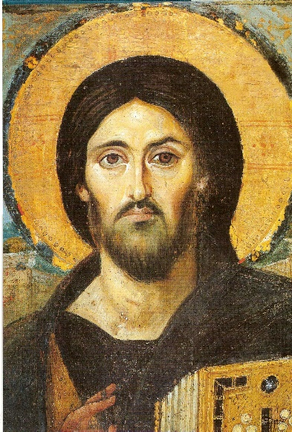
Holy Week
at St. James Episcopal Church, Ormond Beach
38 S. Halifax Drive
Ormond Beach, FL

Return Only THIS Page with your reservation and deposit

