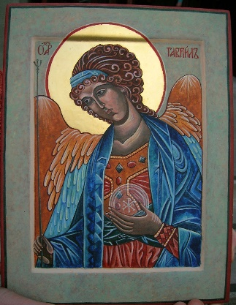

Reservation Information Form
Archangel Gabriel the Messenger

Sacred Windows Icon Workshop December 9 – 12, 2021 @ St. James Episcopal Church
Please fill in the appropriate spaces and mail the completed form and deposit check made out to:
Marcia Allison, 453 Palm Ave. Ormond Beach, FL 32174 M.allison0408@gmail.com 813-417-7525

Name of attendee:
Address:
Best contact number: Email:
Do you have handicap or walking limitations to accommodate: yes/no
Special needs:
Cost includes lunch, traditional icon board & supplies) $450
Dietary Needs:   Gluten free  Low Carb  Vegan/Vegetarian
 Peanut Allergy (other list)
For attendees who are NOT staying overnight; please circle each day of the week needed for meals:

$____________ Amount Enclosed for deposit (recommend $150 now and remaining 10 days prior to event)
$ ____________ Amount Due

Return Only Page ONE with your reservation and deposit

Please join me, beginning the Advent season with the devotion of iconography. In this workshop you will gain insight to entry level icon writing and learn more about the symbolism of the Byzantine style technique. You can also use this time to meditate and come to a deeper spiritual appreciation of the angel Gabriel and the message of the coming Christ Child in this Advent season of your life.

In Luke 1, God sent the angel Gabriel to Mary to tell that she would give birth to the Son of God. “Hail Mary, full of grace, the Lord is with thee (you) . . .” When we say the first part of the Hail Mary, we echo the greeting of the angel Gabriel to Mary in the Gospel of Luke’s infancy narrative. When the angel appeared to Mary, he said, “Greetings, favored one! The Lord is with you. . . [Y]ou have found favor with God” (1:28, 30). When we greet Mary in this way, we acknowledge the special grace that God bestowed upon her in asking her to be the mother of his Son.

Also, in Luke 1 the angel Gabriel was sent to Zechariah to tell of the news that Elizabeth would bear a son. Gabriel, described as “an angel of the Lord,” first appears to Zacharias, the father of John the Baptist. Gabriel tells him, “Fear not, Zacharias: for thy prayer is heard; and thy wife Elisabeth shall bear thee a son, and thou shalt call his name John. And thou shalt have joy and gladness; and many shall rejoice at his birth.” Luke 1:13. After Elizabeth conceived and was six months pregnant, Gabriel appears again. The Book of Luke states he was sent from God to Nazareth to visit the virgin married to a man named Joseph. Gabriel said to Mary, “Hail, thou that art highly favored, the Lord is with thee: blessed art thou among women.” Luke 1:28.

Gabriel is recognized as the patron saint of messengers, telecommunication workers, and postal workers. His feast day is celebrated on September 29.

This course will introduce students to the methods and principles of icon writing. By the end of the course, each participant will complete and take home their icon. Iconography is not a hobby that can be learned in a week but is a vocation that requires the mastering of various skills over years. This workshop is adapted for beginners, novices or excelled artists. Host, Marcia Allison has been studying and writing icons since 2009.
For more information Marcia’s cell phone number is 813-417-7525 or email m.allison0408@gmail.com
Thursday December 2, 2021 – We will begin with Morning Prayer at 8am in the Chapel at St. James Episcopal Church
We will hold our workshop in the art room on the second floor in the annex building, accessible from the front office entrance off Casement Street. We will begin at approx. 8:30am
Lunch will be provided at 12 Noon in Parish Hall.
The afternoon session will vary with time available for 1:1 instruction, group instruction and personal time. We will conclude daily by 4 pm Thur – Sat.
Sunday, the last day we will begin at noon (lunch will not be provided). We will complete our day with a final blessing of our icons.

