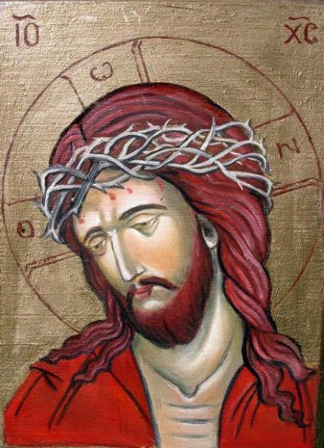
Reservation Information Form
April 15th- 19th, 2019
Crown of Thorns

Please fill in the appropriate spaces and mail the completed form with deposit to:
Marcia Allison, 231 Riverside Dr. Unit 2405 Holly Hill, FL 32117
m.allison0408@gmail.com 813-417-7525

Name of attendee: _____________________________________________________________________
Address:______________________________________________________________________________
Best contact number:_______________________ Email:_______________________________________
Do you have handicap or walking limitations up a flight of stairs: yes/no
Special needs:________________________________________________________________________
Do you play a musical instrument yes/no if yes what instrument_______________________________
Dietary Needs: -Gluten free ; Low Carb ; Vegan/Vegetarian ; Peanut Allergy (other list) ____________________________________________________________________________________
For attendees who are NOT staying overnight; please circle each day of the week needed for meals:
$350 Commuter rate includes boxed lunch:
$_______ Amount Enclosed for deposit (recommend $100 now and remaining 10 days prior to event
$ ____________ Amount Due

Return Only Page ONE with your reservation and deposit

Sacred Windows Icon Workshop presents Crown of Thorns April 15th- 19th, 2019 Holy Week
at St. James Episcopal Church, Ormond Beach
38 S. Halifax Drive
Ormond Beach, FL
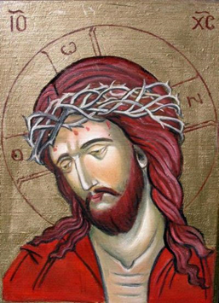

Jesus Sentenced to Be Crucified: Then Pilate took Jesus and had him flogged. The soldiers twisted together a crown of thorns and put it on his head. They clothed him in a purple robe and went up to him again and again, saying, “Hail, king of the Jews!” (John 19:2-3)

Jesus’ own people didn’t respect him. The Jewish people were the ones who had arrested him. They were the ones who had accused him or crime. They were the ones who wanted to kill him. They were the ones who had rejected him. He had let them. Usually kings stand up and fight. You are nervous around them. They are warriors. Jesus? He had gone quietly. He hadn’t spoken at his trial. He quietly took the beating they had just given him. King of the Jews? Not at all. If he was a king, he was unlike any other king on earth. They didn’t realize how right they were. Jesus has control unlike any other king in the world. Jesus ruled in hearts. He shared God’s law to cause people like you and me to cower at our sins. He then shared his Gospel to bring you and I to faith in his power to forgive. (Sermons from Jesus' Enemies, 2015)
He knows you on a personal level. He knows your struggles. He knows your fears. He knows your sin. He knows your guilt. He knows your shame. Join us in knowing him closer this Holy Week in seeing him face to face.
This course will introduce students to the methods and principles of icon writing. By the end of the course, each participant will complete and take home their icon. Iconography is not a hobby that can be learned in a week but is a vocation that requires the mastering of various skills over the years. Teacher, Marcia Allison has been studying and writing icons since 2009 and has hosted numerous daily workshops and overnight retreats.
For more information Marcia’s cell phone number is 813-417-7525 or email m.allison0408@gmail.com
Studio Time 9am – 4:30pm with morning prayer at 8:30am in the Chapel
Lunch will be served at 12 Noon in the Parish Life Center or in the Gardens weather permitting.
The sessions will vary with time available for 1:1 instruction, group instruction and personal time to participate in the weekday Holy Week services. There will be time for rest and reflection to explore for those traveling. If you need recommendations for places to stay, please let Marcia know.
Optional Spiritual Offerings:
Labyrinth
Stations of the Cross
Walks on the beach with the Lord

Sacred Windows Icon Workshop presents Crown of Thorns April 15th- 19th, 2019 Holy Week
at St. James Episcopal Church, Ormond Beach
38 S. Halifax Drive
Ormond Beach, FL

