Reservation Information Form
Sacred Windows Icon Workshop/Retreat October 21 – 26, 2018 @ DaySpring Conference Center
Please fill in the appropriate spaces and mail the completed form and deposit check made out to:
Marcia Allison, 231 Riverside Dr. Unit 2405 Holly Hill, FL 32117. M.allison0408@gmail.com 813-417-7525

Name of attendee:
Address:
Best contact number: Email:
Do you have handicap or walking limitations to accommodate: yes/no
Special needs:
Do you play a musical instrument yes/no if yes what instrument?
For attendees who ARE staying overnight: (cost includes all meals, lodging & supplies)
$820 _________ Double Occupancy room if preference to roommate list name below.
$1000 ________ private room single or $1550 ________Couple Queen bedroom
Roommate Name (double occupancy if known):
Dietary Needs:   Gluten free  Low Carb  Vegan/Vegetarian
 Peanut Allergy (other list)
For attendees who are NOT staying overnight; please circle each day of the week needed for meals:
$600 Commuter rate includes breakfast & lunch meals:
________ Mon, Tues, Wed, Thur, & Fri (brk & lunch only)
________ Sun dinner, Mon dinner, Tues dinner, Wed dinner, Thur dinner (extra $15ea)

$____________ Amount Enclosed for deposit (recommend $150 now and remaining 30 days prior to event for purchase of supplies)
$ ____________ Amount Due
Return Only Page ONE with your reservation and deposit

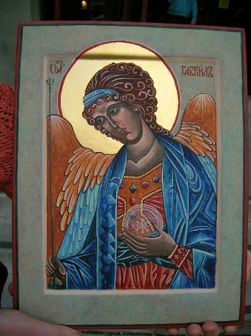

The Holy Archangel Gabriel is an angel who serves as a messenger for God to certain people. Gabriel is one of the three archangels. Gabriel is mentioned in both the Old and the New Testaments of the Bible. First, in the Old Testament, Gabriel appears to the prophet Daniel to explain his visions. Speaking to Daniel while he is sleeping. After Gabriel’s first visit, Daniel becomes tired and sick for days. Gabriel later visits Daniel again providing him with more insight and understanding in an answered prayer.

In the New Testament, Gabriel, described as “an angel of the Lord,” first appears to Zacharias, the father of John the Baptist. Gabriel tells him, “Fear not, Zacharias: for thy prayer is heard; and thy wife Elisabeth shall bear thee a son, and thou shalt call his name John. And thou shalt have joy and gladness; and many shall rejoice at his birth.” Luke 1:13. After Elizabeth conceived and was six months pregnant, Gabriel appears again. The Book of Luke states he was sent from God to Nazareth to visit the virgin married to a man named Joseph. Gabriel said to Mary, “Hail, thou that art highly favoured, the Lord is with thee: blessed art thou among women.” Luke 1:28.

Gabriel is occasionally cited as the one who blows God’s trumpet to indicate the Lord’s return to Earth. However, the person designated with this task varies; different passages cite different people. The earliest known identification of Gabriel as the trumpet holder comes in 1455 represented in Byzantine art.

Gabriel is recognized as the patron saint of messengers, telecommunication workers, and postal workers. His feast day is celebrated on September 29, along with St. Michael and St. Raphael.

This course will introduce students to the methods and principles of icon writing. By the end of the course, each participant will complete and take home their icon. Iconography is not a hobby that can be learned in a week but is a vocation that requires the mastering of various skills over the years. Teacher, Marcia Allison has been studying and writing icons since 2009 and this is her 3rd workshop / retreat offered at DaySpring Conference Center.
For more information Marcia’s cell phone number is 813-417-7525 or email m.allison0408@gmail.com

Details on how to locate DaySpring can be found at their website at https://dayspringfla.org
Sunday October 21, 2018 – check-in begins at 4:00 PM in the Pool House
Dinner will be served in Curry Hall at 6. Daily Monday - Friday, Oct 22-26, 2018 (Meal times subject to change with DaySpring schedule)
Daily Chapel 7:30am in St. Thomas Chapel
Breakfast will be served at 8 AM in Curry Hall.
Studio Time 9am – 11:30 ending with Noon Day Prayers
Lunch will be served at 12 Noon in Curry Hall.
The afternoon session will vary with time available for 1:1 instruction, group instruction and personal time. There will be time for rest and reflection to explore DaySpring on your own before dinner.
After lunch (noon) on the last day we will have a blessing of the icons Eucharist service at St. Thomas Chapel. Check-out is 10am, and keys to be turned in after breakfast on Oct. 26th unless arrangements for extra night are made in advance. We will be able to use classroom for the remainder of the day if needed (4pm).

Optional Spiritual Offerings:
Labyrinth
Stations of the Cross
DaySpring Canopy Walk
Canoeing/Kayaking

