Reservation Information Form
Please fill in the appropriate spaces and mail the completed form to: Marcia Allison, 231 Riverside Dr. Unit 2405 Holly Hill, FL 32117. M.allison0408@gmail.com 813-417-7525
Name of attendee: _____________________________________________
Address:______________________________________________________________________________
Best contact number:_______________________ Email:_______________________________________ Do you have handicap or walking limitations to accommodate: yes/no
Special needs:________________________________________________________________________
Do you play a musical instrument yes/no if yes what instrument_______________________________
For attendees who ARE staying overnight: (cost includes all meals, lodging & supplies)
$850 _________ Double Occupancy room if preference to roommate list name below.
$1000 ________ private room single or $1550 ________Couple Queen bedroom
Roommate Name (double occupancy if known): ___________________________________________
Dietary Needs: -Gluten free ; Low Carb ; Vegan/Vegetarian ; Peanut Allergy (other list) ____________________________________________________________
For attendees who are NOT staying overnight; please circle each day of the week needed for meals:
$600 Commuter rate includes breakfast & lunch meals:
________ Mon, Tues, Wed, Thur, & Fri (brk & lunch only)
________ Sun dinner, Mon dinner, Tues dinner, Wed dinner, Thur dinner (extra $15ea)
$_______ Amount Enclosed for deposit (recommend $150 now and remaining 30 days prior to event for purchase of supplies)
$ ____________ Amount Due

Return Only Page ONE with your reservation and deposit

Sacred Windows Icon Workshop/Retreat October 6-11, 2019 @ DaySpring Conference Center
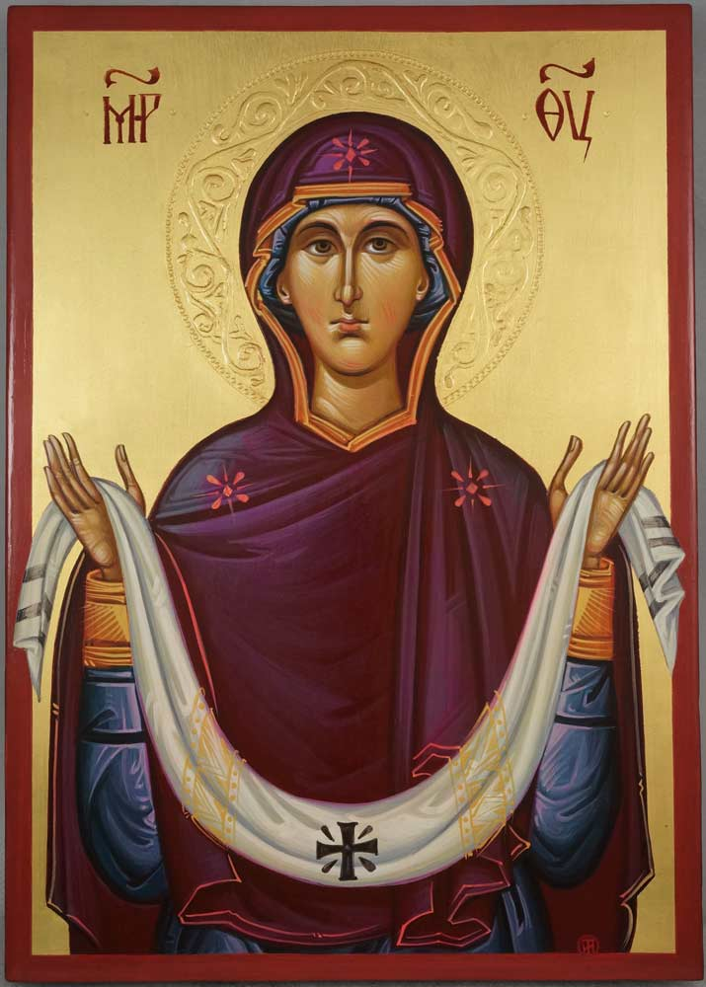

“We flee under your compassion for refuge, Birthgiver of God; do not despise our prayers when troubles surround us, but deliver us from danger, only pure one, only blessed one.” (earliest known prayer to Mary found in Egypt, the land of Goddess Isis)

The Protection of the Mother of God is one of the most beloved feast days on the Orthodox calendar among the Slavic peoples, commemorated on October 1. This retreat workshop will be portraying the image of our lady. The icon is called Pokrovitelnitsa, “The Protectress” also found as Pokrov icon. Its origin lies in the story that in the year 902 (some say 911) c.e., the people of Constantinople gathered in the Church of the Vlakhernae (Blachernae), fearing a military invasion; some say the invaders were Saracens (Muslims), some say a fleet of northerners from what was then called Rus. During the all-night prayer vigil, Андрей Юродивый — Andrei Yurodivuiy — Andrei the “Holy Fool” — supposedly had a vision in which he saw Mary standing in the church, taking off her veil, and holding it over the congregation as a covering sign of her protection. With her were various saints and angels. (David, 2015) The image portrays her in the full view upon a cloud appearing above a crowd holding the veil for protection.

There is much more to be said about the Pokrov and the customs and beliefs associated with it in Russian folk life. If such things interest you, an excellent book to read is Ivan the Fool: Russian Folk Belief, (Glas, English translation 2007) by Andrei Sinyavsky. The book is rich in information relating to icons in Russia.

Luke 1:46 recognizes Mary as blessed when Elizabeth exclaimed with a loud cry, “Blessed are you among women, and blessed is the fruit of your womb. Then of course we find the Magnificat in 46-55:

Mary’s Song of Praise
And Mary said, “My soul magnifies the Lord,
and my spirit rejoices in God my Savior,
for he has looked with favor on the lowliness of his servant.
Surely, from now on all generations will call me blessed;
for the Mighty One has done great things for me, and holy is his name.
His mercy is for those who fear him from generation to generation.
He has shown strength with his arm; he has scattered the proud in the thoughts of their hearts
He has brought down the powerful from their thrones, and lifted up the lowly;
he has filled the hungry with good things and sent the rich away empty.
He has helped his servant Israel, in remembrance of his mercy, according to the promise he made to our ancestors, to Abraham and to his descendants forever.”

This course will introduce students to the methods and principles of icon writing. By the end of the course, each participant will complete and take home their icon. Iconography is not a hobby that can be learned in a week but is a vocation that requires the mastering of various skills over the years.
Teacher, Marcia Allison has been studying and writing icons since 2009 and this is her 4th workshop/ retreat offered at DaySpring Conference Center.

For more information Marcia’s cell phone number is 813-417-7525 or email m.allison0408@gmail.com

Details on how to locate DaySpring can be found at their website at https://dayspringfla.org
Sunday October 6, 2019 – check-in begins at 4:00 PM in the Pool House
Dinner will be served in Curry Hall at 6. Daily Monday - Friday, Oct 7-11, 2019 (Meal times subject to change with DaySpring schedule)
Daily Chapel 7:30am in St. Thomas Chapel
Breakfast will be served at 8 AM in Curry Hall.
Studio Time 9am – 11:30 ending with Noon Day Prayers
Lunch will be served at 12 Noon in Curry Hall.
The afternoon session will vary with time available for 1:1 instruction, group instruction and personal time. There will be time for rest and reflection to explore DaySpring on your own before dinner.
After lunch (noon) on the last day we will have a blessing of the icons Eucharist service at St. Thomas Chapel. Check-out is 10am, and keys to be turned in after breakfast on Oct. 11th unless arrangements for extra night are made in advance. We will be able to use classroom for the remainder of the day if needed (4pm).

Optional Spiritual Offerings:
Labyrinth
Stations of the Cross
DaySpring Canopy Walk
Canoeing/Kayaking

